**Day 4 and 5**

**Computer Fundamental & Git Notes**

**VMware VMFS** (**Virtual Machine File System**) is [VMware](https://en.wikipedia.org/wiki/VMware), Inc.'s [clustered file system](https://en.wikipedia.org/wiki/Clustered_file_system) used by the company's flagship server virtualization suite, [vSphere](https://en.wikipedia.org/wiki/VSphere" \o "VSphere). It was developed to store [virtual machine disk images](https://en.wikipedia.org/wiki/Virtual_machine_image), including snapshots. Multiple servers can read/write the same filesystem simultaneously while individual virtual machine files are locked. VMFS volumes can be logically "grown" (non-destructively increased in size) by spanning multiple VMFS volumes together.

Imp: [VMware VMFS - Wikipedia](https://en.wikipedia.org/wiki/VMware_VMFS)

[What is Linux? - Linux.com](https://www.linux.com/what-is-linux/)

[Paging in Operating System - GeeksforGeeks](https://www.geeksforgeeks.org/paging-in-operating-system/)

Paging is a function of memory management where a computer will store and retrieve data from a device’s secondary storage to the primary storage. Memory management is a crucial aspect of any computing device, and paging specifically is important to the implementation of virtual memory.

**How paging works**

Paging works by writing [data](https://www.techtarget.com/searchdatamanagement/definition/data) to, and reading it from, [secondary storage](https://www.techtarget.com/searchstorage/definition/secondary-auxiliary-storage) for use in [primary storage](https://www.techtarget.com/searchstorage/definition/primary-storage). Paging is a basic function in memory management for a computer's operating system ([OS](https://www.techtarget.com/whatis/definition/operating-system-OS)) as well -- this includes Windows, Unix, Linux and macOSs.

In a memory management system that takes advantage of paging, the OS reads data from secondary storage in blocks called pages, all of which have identical size. The physical region of memory containing a single page is called a frame. When paging is used, a frame does not have to comprise a single physically contiguous region in secondary storage. This approach offers an advantage over earlier memory management methods, because it facilitates more efficient and faster use of storage.

Version Control System:

1. Centralized version Control System
2. Distributed Version Control System

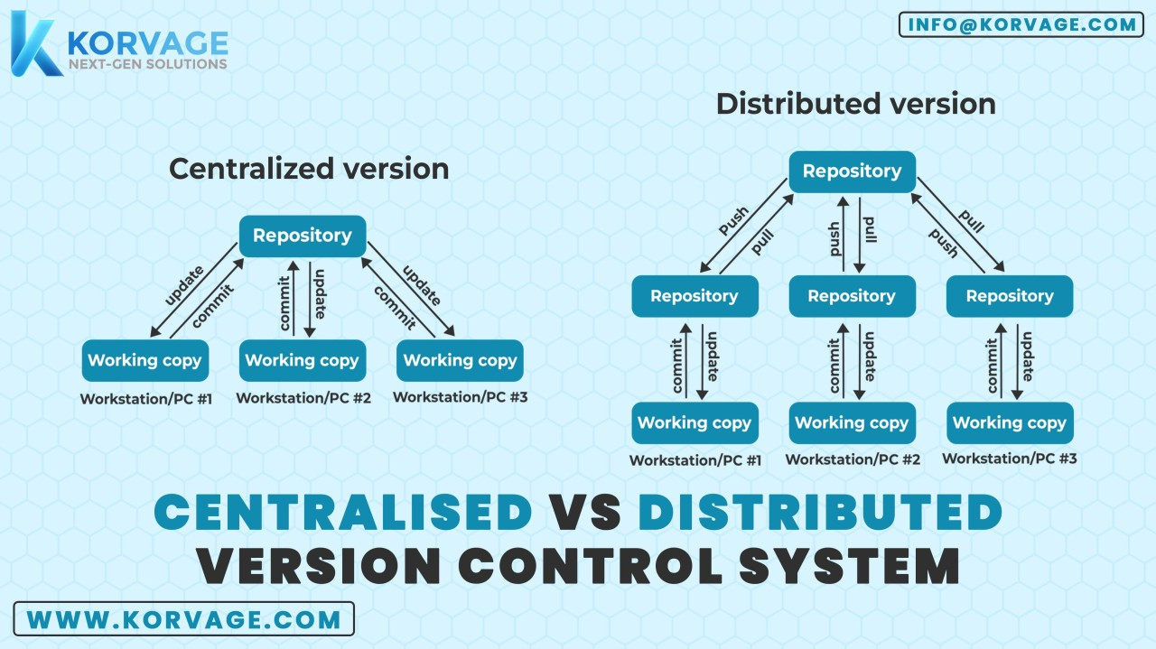

user.email=yogeshrahangdale27@gmail.com

user.name=yogeshrahangdale

<https://github.com/settings/tokens>

git branch workingcopy 555 git branch 556 git branch wk2

557 git branch 558 git checkout workingcopy 559 ls 560 git checkout main 561 ls 562 git checkout workingcopy 563 ls 564 touch c d e 565 ls 566 git diff 567 git add d e 568 git commit -m "branchcommit" 569 git push origin 570 git push origin workingcopy 571 git checkout main 572 git merge workingcopy 573 git push origin

main 574 git branch sanwile 575 git sanwile 576 git branch 577 ls 578 git checkout sanwile 579 touch san1 san2 san3 580 git add . 581 git commit -m "sancommits" 582 ls 583 git push origin sanwile 584 git checkout main 585 git merge sanwile 586 git push origin main 587 history

git clone https://github.com/techmarathon/gitfileswi.git 543 ls 544 cd gitfileswi/ 545 ls 546 git add . 547 git commit -m "firstcommits" 548 ls 549 touch a b c 550 git add . 551 git commit -m "firstcommits" 552 git push origin main

Computer FundamentalsArchitecture & SDLC GIT Basics Activity: Git Basics Quiz: Git Basics

# both having work for create a branch

git branch <branch name>

git checkout<branch name> (both having work for create a branch)

# Show a graph of all branches, both local and remotegit show-branch -a

# List all local branchesgit branch# List all remote branchesgit branch -r# List all branches, both local and remotegit branch –a

# create new branch

git checkout –b <branch name>

# this all three have a same work

git add . && git add * && git add –all (all these three have same work) imp

#### Git versus GitHub

**Git** is a separate technology from **GitHub**, and you need BOTH to manage your repository.

* **Git** is software that you must install on your computer. It manages and tracks changes to files in your local repository so that it can report those changes to GitHub when you synchronize your local files with your remote repository files.
* **GitHub** is a website that provides Git hosting services. You must create an account in GitHub before you can create a remote repository for your files.

CSMA/CD is one such technique where different stations that follow this protocol agree on some terms and collision detection measures for effective transmission.

[Collision Detection in CSMA/CD - GeeksforGeeks](https://www.geeksforgeeks.org/collision-detection-csmacd/)

Hub : A hub is a multi-port repeater. A hub connects multiple wires coming from different branches, for example, the connector in star topology which connects different stations.

Repeater : In telecommunications, a repeater is**an electronic device that receives a signal and retransmits it.** Repeaters are used to extend transmissions so that the signal can cover longer distances or be received on the other side of an obstruction.

SWITCH : It is an advanced device which can selectively forward the data packets.

Gateway: A device that connects and translates communications between different network protocols.

A bridge in a computer network is a device used to connect multiple LANs together with a larger Local Area Network (LAN). The mechanism of network aggregation is known as bridging.

Bridge : It acts as a mediator between two or more network devices/segments together & forwards the traffic between them.